**CS553 – CLOUD COMPUTING**

**PROJECT**

**Understanding the Cost of Computing in the Cloud**

**Suraj Kumar Didwania (A20334147)**

**Vivek Sagar Sahu (A20375371)**

The project is about the evaluation of the private cloud cost and public cost clouds. Whether a start-up should opt for public or private cloud.

**Private Cloud:**

Private cloud is a type of cloud computing that delivers similar advantages to public cloud, including scalability and self-service, but through a proprietary architecture. Unlike public clouds, which deliver services to multiple organizations, a private cloud is dedicated to a single organization.

**Public Cloud:**

A public cloud is one based on the standard cloud computing model, in which a service provider makes resources, such as virtual machines (VMs), applications or storage, available to the general public over the internet. Public cloud services may be free or offered on a pay-per-usage model.

**Private Cloud:**

**Configuration 1:**

Hadoop/Spark Cluster with 32K-cores, 256TB memory, 50PB HDD, and 10Gb/s Ethernet Fat-Tree network (each VM should be equivalent to the d2.8xlarge instance); in addition to the compute resources, a 100PB distributed storage shared across the entire cloud should be procured, with enough capacity for 100GB/sec throughput (for pricing comparison, see S3)

High-frequency Intel Xeon E5-2676 v3 (Haswell) processors

|  |  |  |  |  |
| --- | --- | --- | --- | --- |
|  | Description | Price per Item | Quantity | Total Price |
| Compute Servers | 2 processor ­­­­(Intel E5-2676 v3) using 38TB Hard drives with 32*6 GiB memory all in 2U Rackmount server | $9527.54 | 1334 | $12,709,738.36 |
| Network Switches | 40 GbE switch with 32 ports has been used. (Leaf switch 38 swine switch 19) | $19,600 | 57 | $1,117,200 |
| Network Cables | Dell Networking 331-8153 Compatible 40G QSFP+ to 4x10G SFP  Used. | $110 $79 | 594 594 | $112,266 |
| Racks | 48U rack has been used to load Compute server, storage server and switches.123 racks shelves. | $1790.64  $34.99 | 123 2376 | $303,384.96 |
| Storage Servers | 96 TB Storage server with required throughput | $8698.84 | 1042 | $8,907,612.16 |
| Electric Power | Average power rate required. | $0.12 | 109,075,377.60 | $13,089,045.312 |
| Cooling | Cooler for 2 racks each  Cooling Unit Air Conditioner, AC, 24K BTU (7 kW) | $2716.99 | 62 | $168,453.38 |
| Administration | System Administrator rate for the US to handle servers (2376 servers) | $85,000*5 = $425,000 | 3 | $1,275,000 |
| TOTAL |  |  |  | $37,682,700.17 |
|  |  |  |  |  |

**Compute Servers:**

The compute servers required to make the Hadoop and Spark Cluster is been assembled using below products.

1. Rackmount server with the same processor and socket requirement. Rackmount server is compatible with the Intel Xeon E5-2676 v3 and Socket 2011. The processor is required by d2.8xlarge instance. A rack server makes upto 24 physical cores i.e. 32000/24 = 1334 nodes.
2. It requires 192 GB of memory as 256 TB/1334. 6*32GB RAM has been selected.
3. 38 TB of HDD required and which amount to 8 GB*4 + 6GB
4. Intel Xeon E5-2676 v3 Processor has been selected.
5. Network Interface card.

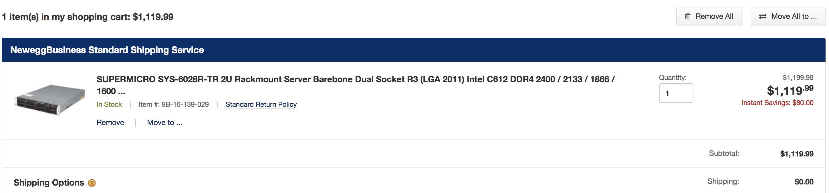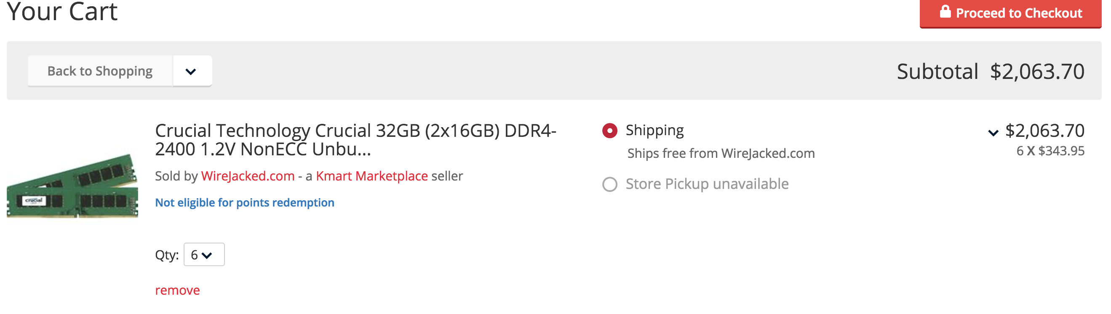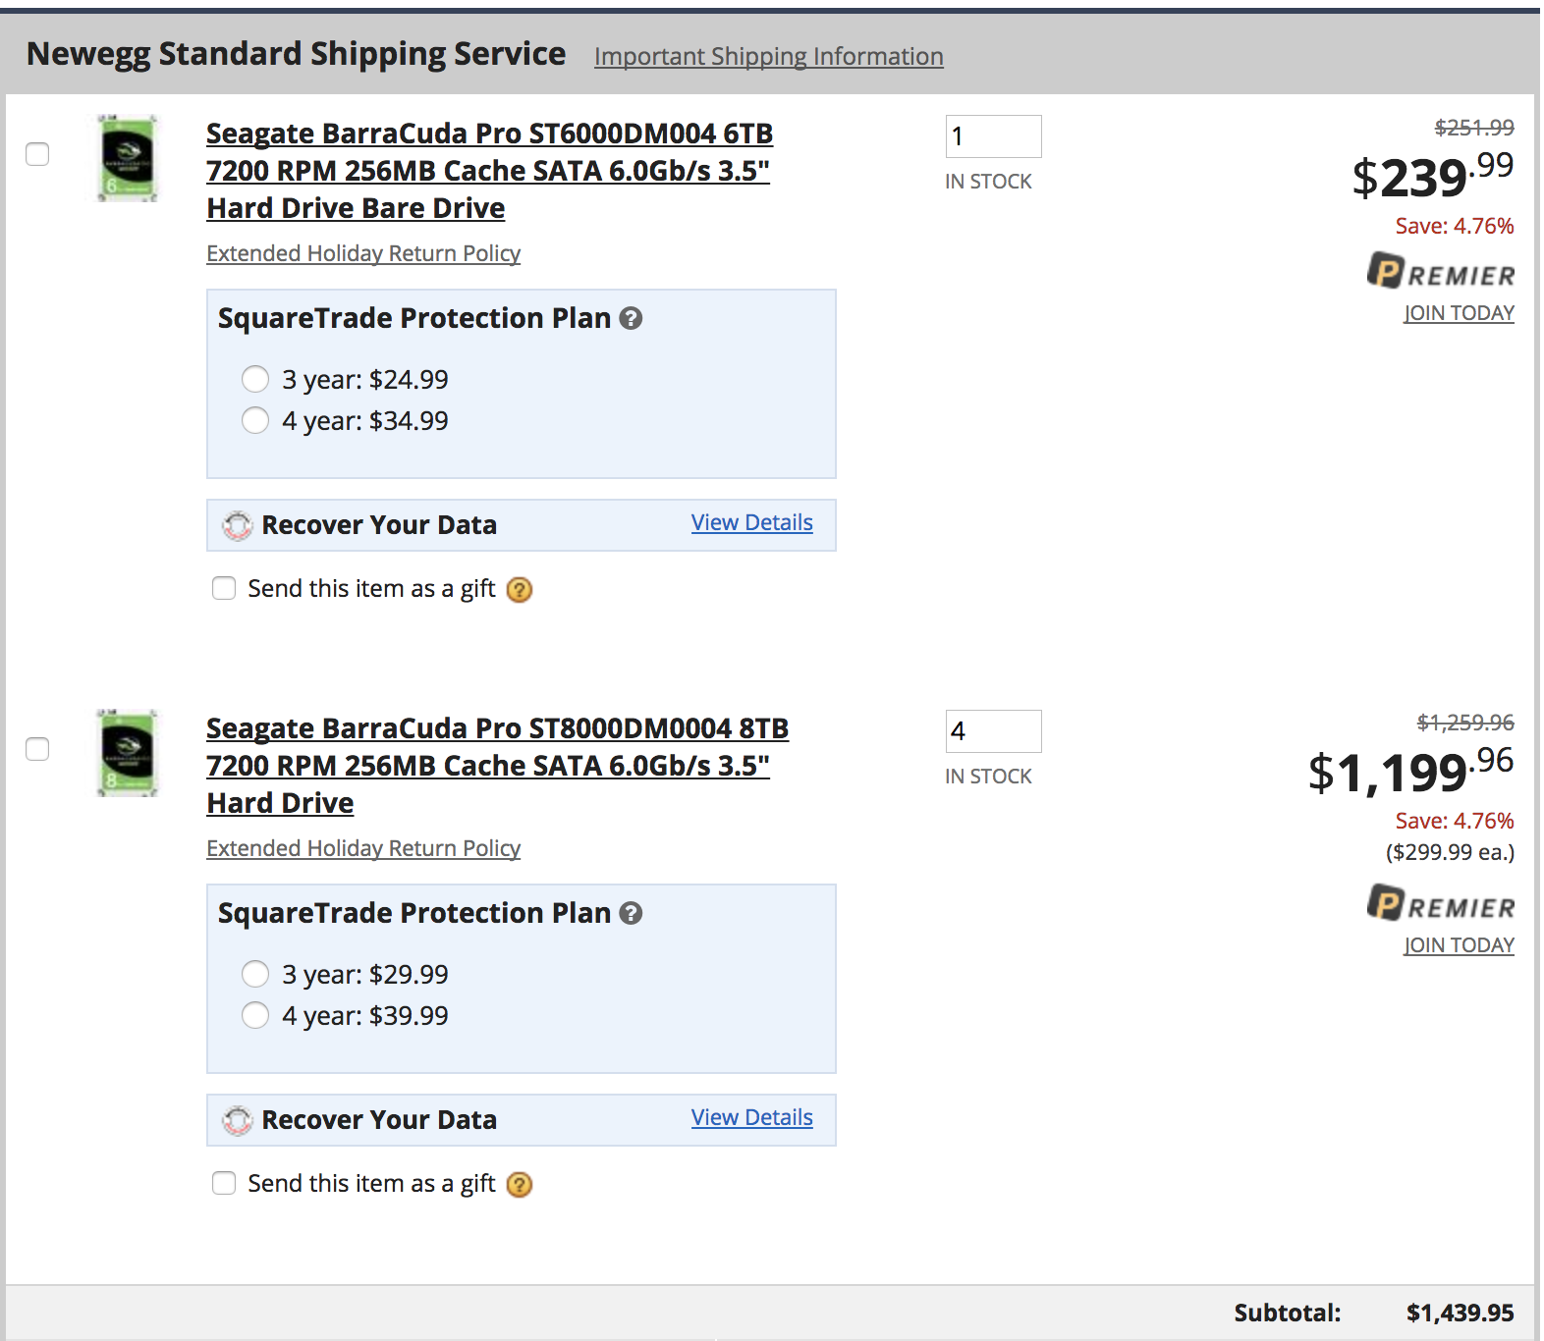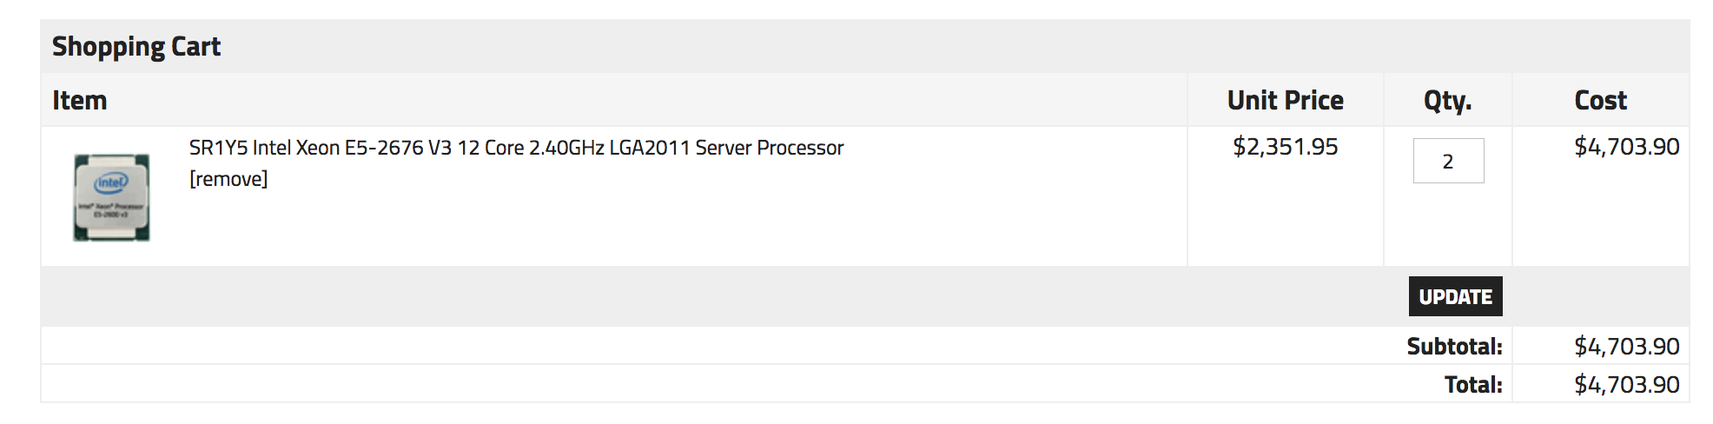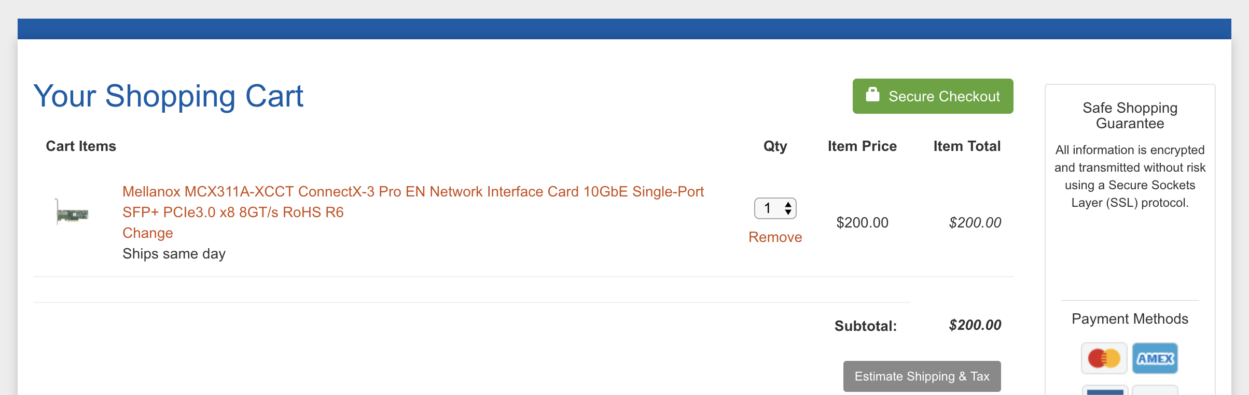

**Network Switches:**

To form the required fat tree Network with the switches. Leaf switches port has been converted from 40GiE to 10Gb. We required totally 57 switches totally to capture totally 1334 compute and 1042 storage server.

Each switch cost us $19,600

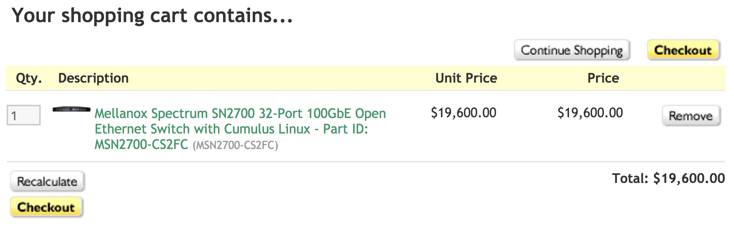

**Network Cables:**

Cables have been selected as the process of forming the fat tree network among switches. Leaf switch requires 40 to 10G cable and spine switch required normal cable.

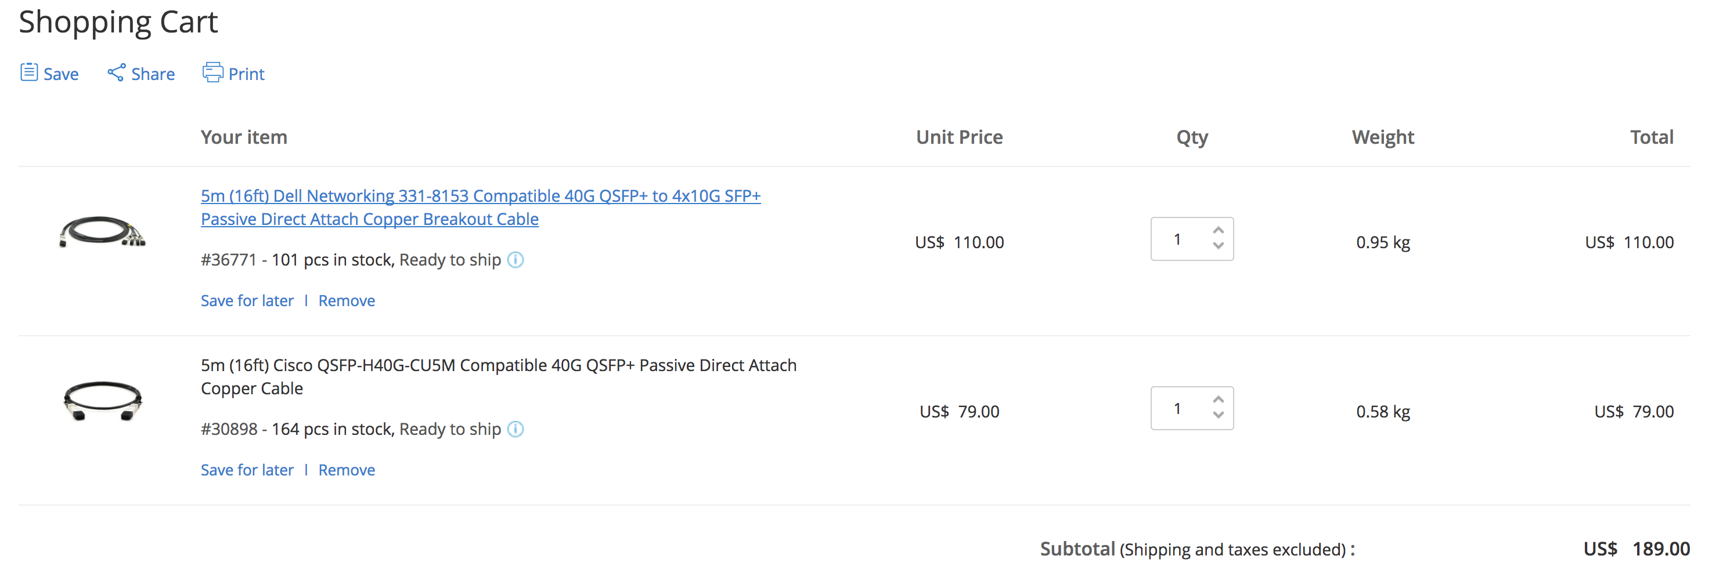

**Racks**:

48U rack selected to fit compute server, storage server and switches. A 2U cabinet selected to fit each of servers and switches.

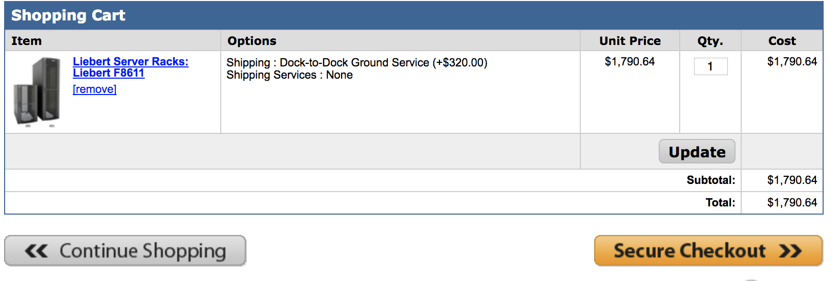



**Storage Server:**

Storage Server has been built using NAS Workstation and 6Tb hard drive. 16 hard drive has been used to form 96TB drive. We require 1042 storage server. This configuration enables us to have 100GB/s + throughput.

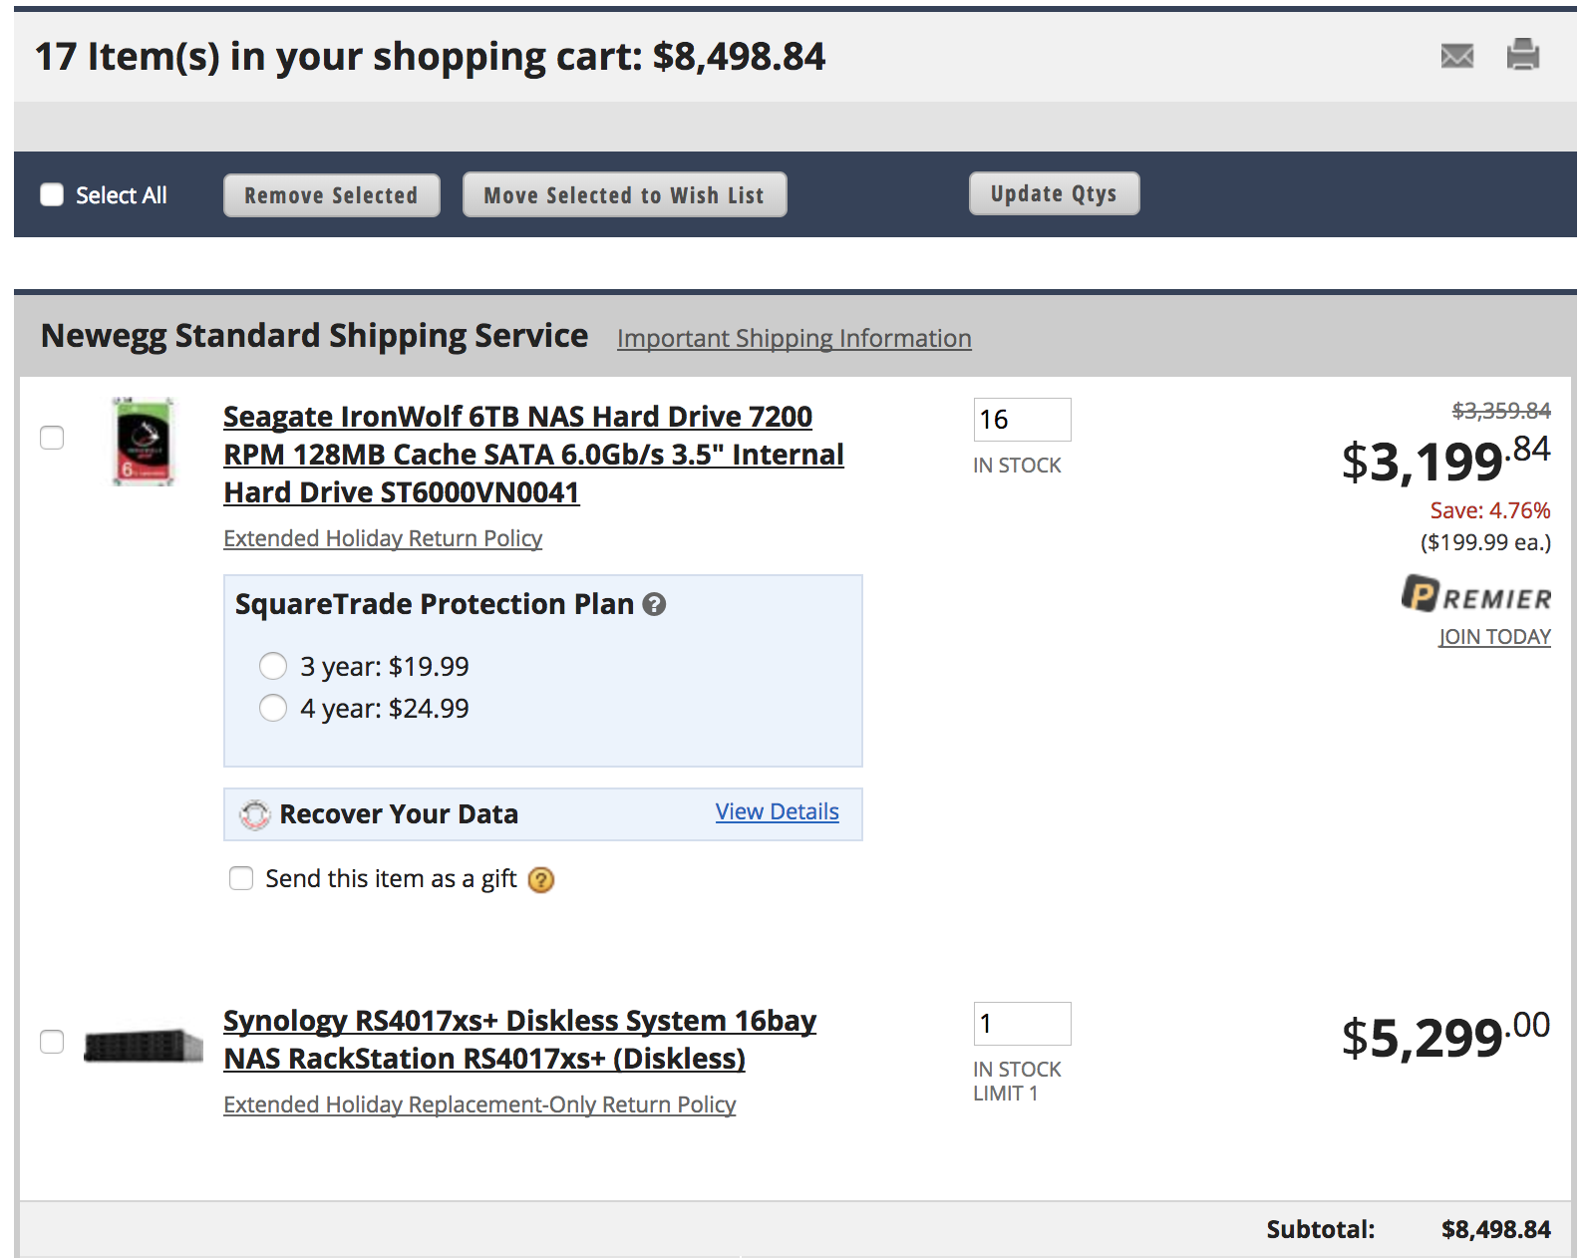



**Electric Power:**

Average power rate in USA is $0.12/KW.

Compute server = 1334*740W = 987.160 KW

Storage server = 1042* 1.05 = 1094.1 kW

Switches = 57*169 W = 9.633 kW

Cooling = 62*7kW = 434 kW

**Cooling of racks:**

To cool the racks with the server, cooler which can handle two racks has been selected with the optimal cost. The power required is 7kW.

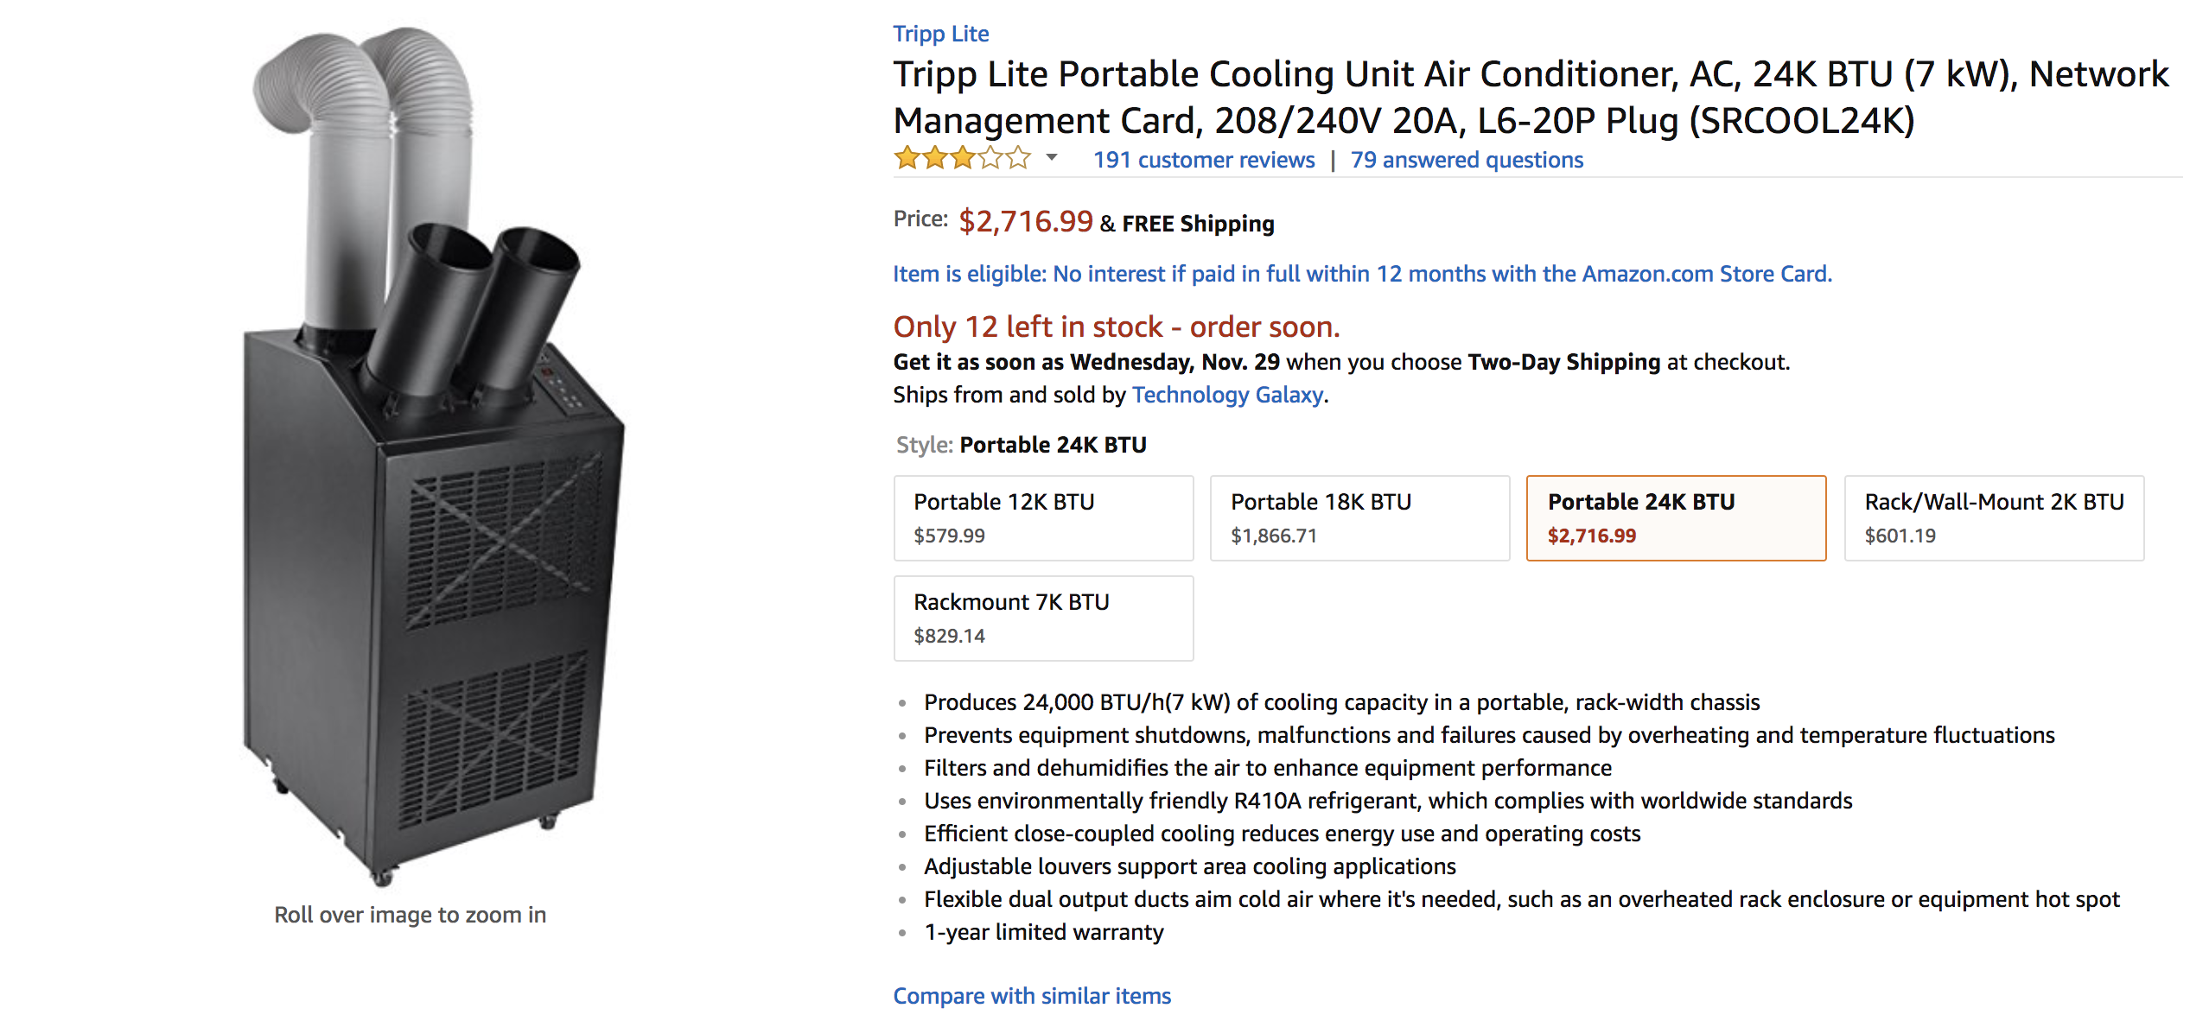

**Administrator:**

We require 3 admin to handle the private cloud as we need more than 2000 servers. Average admin cost comes to $85,000 including perks.

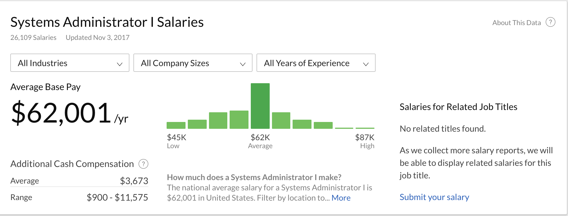

**Configuration 2:**

Support 1 million virtual machines (VM) where each VM requires 2-core, 15GB RAM, 32GB SSD storage, and 1Gb/s Fat-Tree network (each VM should be equivalent to the r3.large instances); in addition to the compute resources, a 10PB distributed storage shared across the entire cloud should be procured, with enough capacity for 10GB/sec throughput (for pricing comparison, see S3)

Intel Xeon E5-2670 v2

SSD Storage

No of cores: 10

No of threads:20

# QP links:2

|  |  |  |  |  |
| --- | --- | --- | --- | --- |
|  | Description | Price per Item | Quantity | Total Price |
| Compute Servers | Rackmount server with 320 GB SSD and 32*5 GB RAM and Intel Xeon E5-2670 v2  Processor with NIC. | $6502 | 100000 | $650,220,000 |
| Network Switches | 324 port network switch is used as leaf switch(155) and swine switch(78) | $31,980 | 233 | $7,451,340 |
| Network Cables | Dell Networking 331-8153 Compatible 40G QSFP+ to 4x10G SFP  Used. | $110 $79 | 25027 25027 | $4,730,103 |
| Racks | 48U rack has been used to load Compute server, storage server and switches | $1,790.64 $34.99 | 2167 100,338 | $7,391,143.5 |
| Storage Servers | 96 TB Storage server with required throughput | $8698.84 | 105 | $913,378.2 |
| Electric Power | Average power rate required. | $0.12 | 3,574,265,486.4 | $428,911,858.368 |
| Cooling | Cooler for 2 racks each  Cooling Unit Air Conditioner, AC, 24K BTU (7 kW) | $2,716.99 | 1084 | $2,945,217.16 |
| Administration | System Administrator rate for the US to handle servers (2376 servers) | $425,000 | 101 | $42,925,000 |
| TOTAL |  |  |  | **$**1,145,488,040.228 |

**Compute Server:**

The compute servers required to make the Hadoop and Spark Cluster is been assembled using below products.

Rackmount server with the same processor and socket requirement. Rackmount server is compatible with the Intel Xeon E5-2670 v2 and Socket 2011. The processor is required by r3.large instance. A rack server makes upto 24 physical cores i.e. 2000000/20 = 100000 compute server.

1. It requires 160 GB of memory.
2. 320 GB of SSD required and which amount to $800.00 approx.
3. Intel Xeon E5-2670 v2 processor has been selected.
4. Network Interface card.

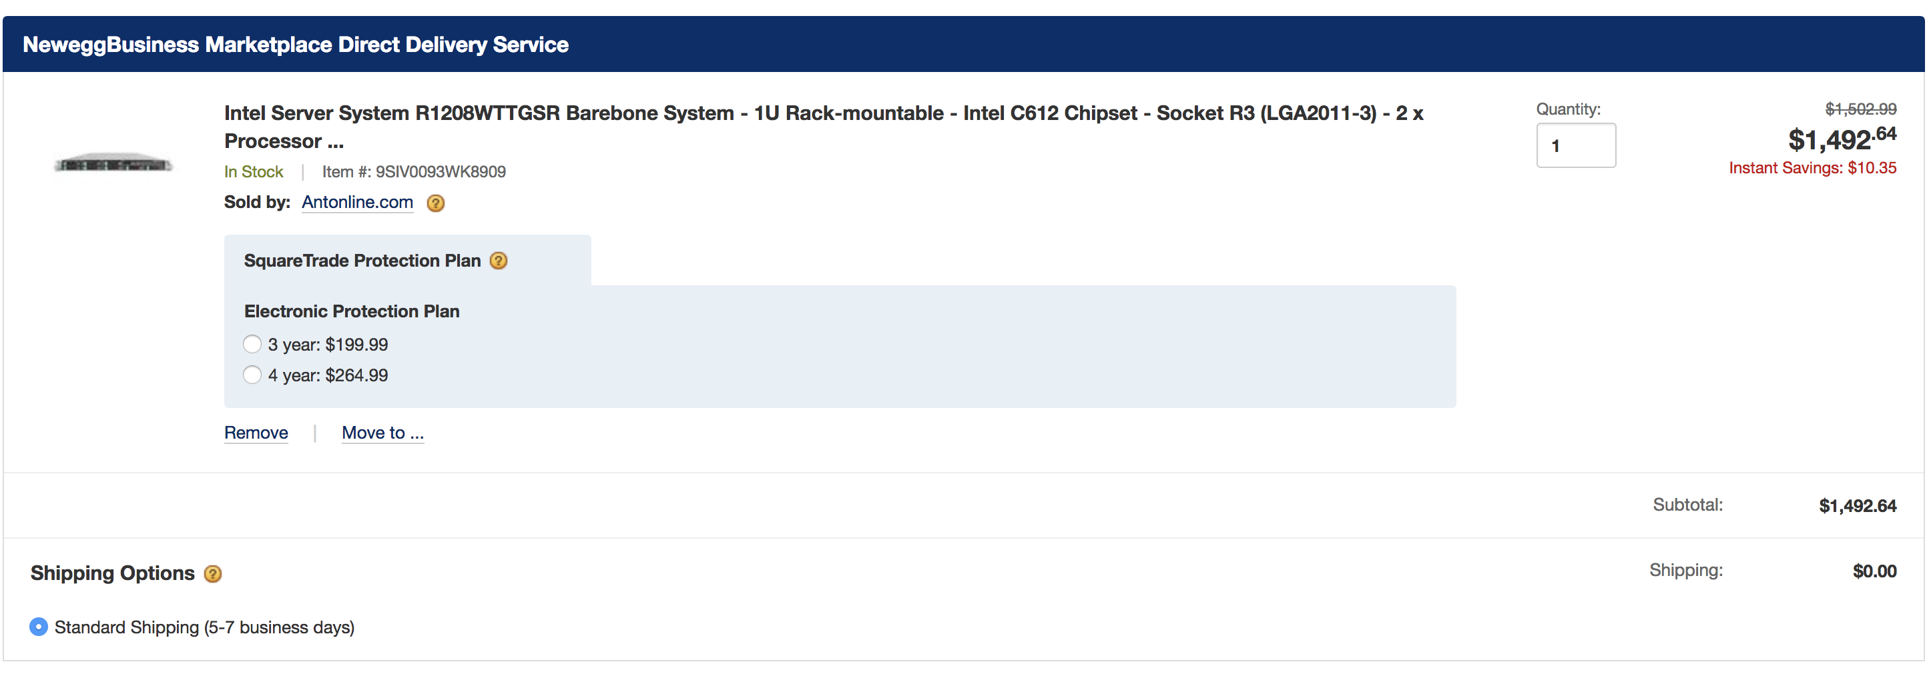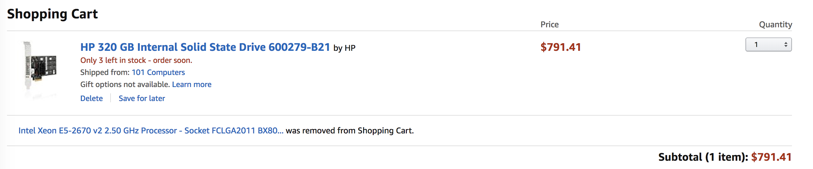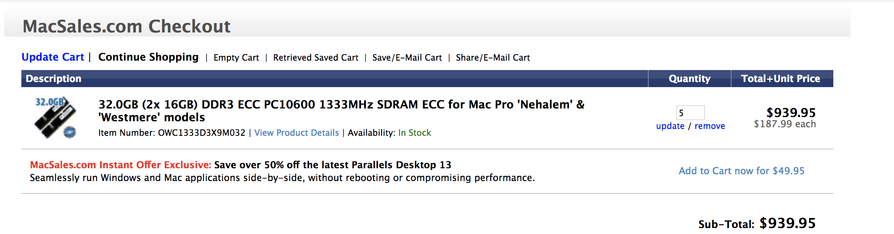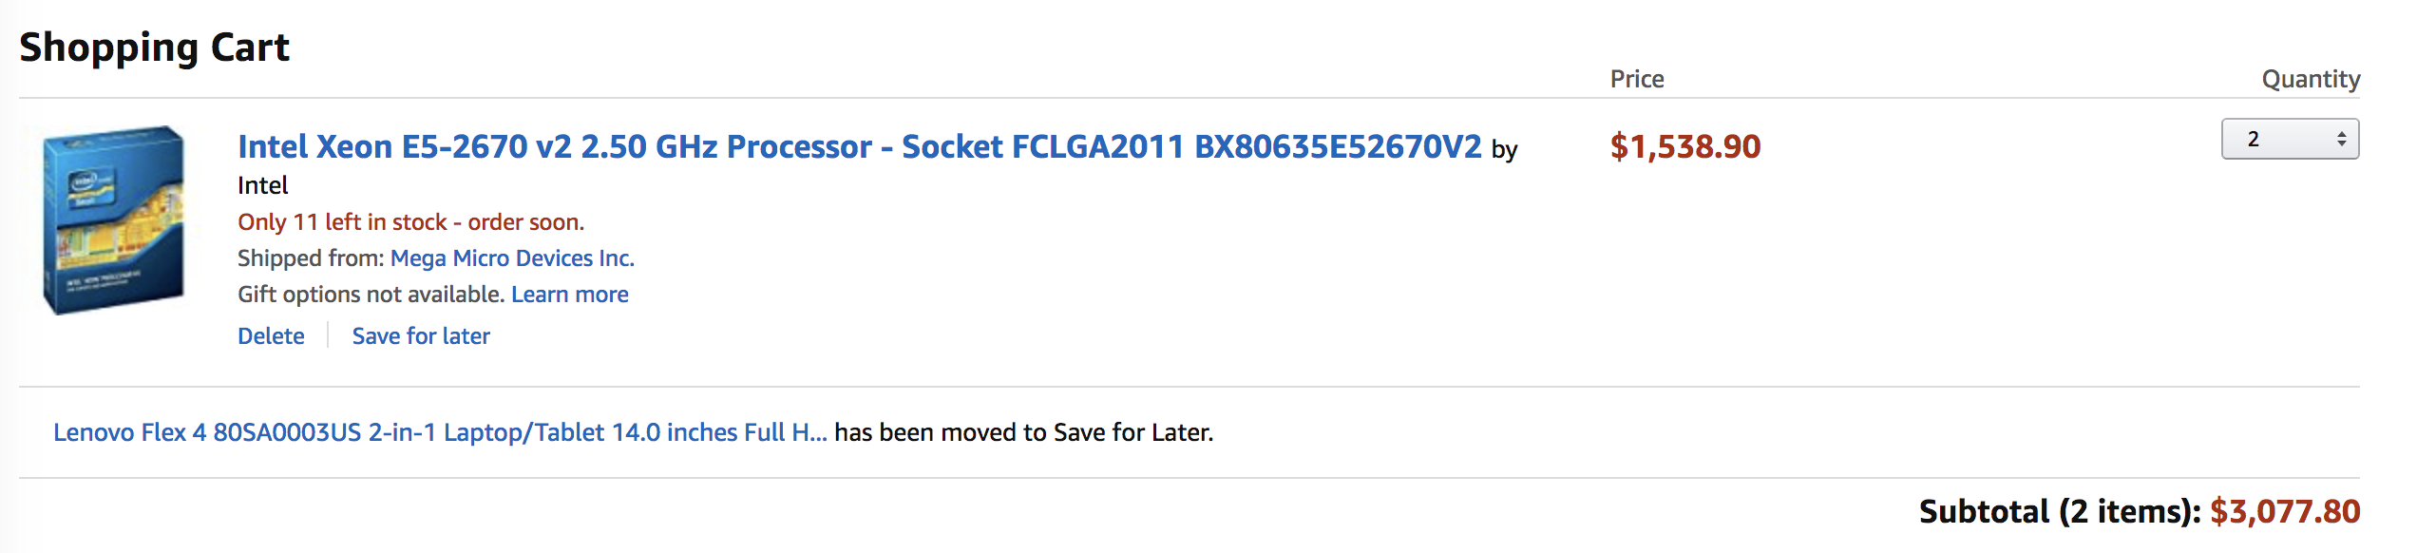



**Network Switches:**

To form the required fat tree Network with the switches. Leaf switches port has been converted from 40GiE to 10Gb. We required totally 233 switches totally to capture totally 100000 compute and 105 storage server.

Each switch cost us $31,980

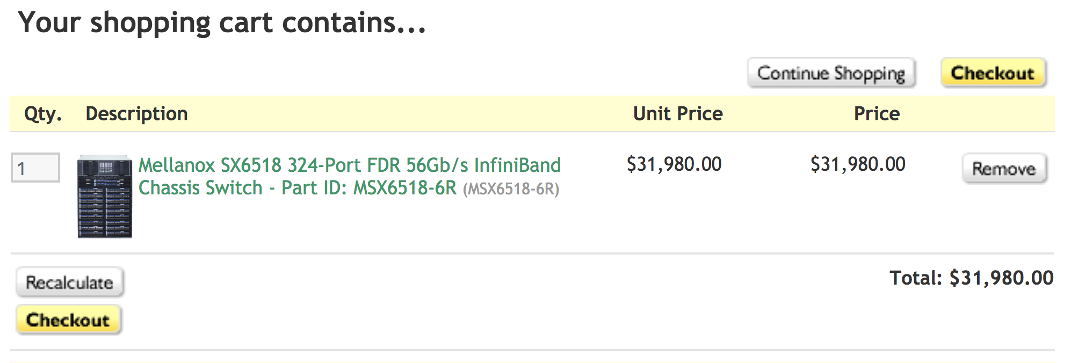

**Network Cables:**

Cables have been selected as the process of forming the fat tree network among switches. Leaf switch requires 40 to 10G cable and spine switch required normal cable.



**Racks**:

48U rack selected to fit compute server, storage server and switches. A 2U cabinet selected to fit each of servers and switches.





**Storage Servers:**

Storage Server has been built using NAS Workstation and 6Tb hard drive. 16 hard drive has been used to form 96TB drive. We require 105 storage servers. This configuration enables us to have 10GB/s + throughput.





**Electric Power:**

Average power rate in USA is $0.12/KW.

* Compute server = 100000* 750W = 75,000 KW

Storage server = 105* 1.05 = 110.25 kW

Switches = 233*169 W = 39.377 kW

Cooling = 1084*7kW = 7,588 kW

**Cooling of racks:**

To cool the racks with the server, cooler which can handle two racks has been selected with the optimal cost. The power required is 7kW.



**Administrator:**

We require 3 admin to handle the private cloud as we need more than 2000 servers. Average admin cost comes to $85,000 including perks.



**Configuration 3:**

Configuration 3: Support deep learning with 1 exaflop of mixed precision performance (hint: each VM should be equivalent to p3.16xlarge instances; you will want to use the NVIDIA V100 GPUs (8 GPUs per node), and allocate 8-cores per GPU (64-cores per node) with 8GB of memory per core (512GB per node); the network to use is at least 10Gb/s per GPU (100Gb/s should work), and should be organized in a Fat-Tree network; in addition to the compute resources, a 1PB distributed storage shared across the entire cloud should be procured, with enough capacity for 10GB/sec throughput (for pricing comparison, see S3)

* Up to 8 NVIDIA Tesla V100 GPUs, each pairing 5,120 CUDA Cores and 640 Tensor Cores
* High frequency Intel Xeon E5-2686 v4 (Broadwell) processors

|  |  |  |  |  |
| --- | --- | --- | --- | --- |
|  | Description | Price per Item | Quantity | Total Price |
| Compute Servers | NVIDIA CORP [8-GPU/512GB DGX-1 DL WITH V100](http://www.nextwarehouse.com/item/?2707240)  Required 1000 server to accomplish the task | $154,766.06 | 1000 | $154,766,060 |
| Network Switches | 48 port network switch with 100 GbE | $10,835.00 | 64 | $693,440 |
| Network Cables | Mellanox MCP1600-E002 Passive Copper Cable IB EDR up to 100Gb/s | 115 | 2022 | $232,530 |
| Racks | 48U rack has been used to load Compute server, storage server and switches | $1,790.64 $34.99 | 44 … 1075 | $152,215.21 |
| Storage Servers | 96 TB Storage server with required throughput | $8,698.84 | 11 | $95,687.24 |
| Electric Power | Average power rate required. | $0.12 | 141,765,120 | $17,011,814.4 |
| Cooling | Cooler for 2 racks each  Cooling Unit Air Conditioner, AC, 24K BTU (7 kW) | $2,716.99 | 22 | $59,773.78 |
| Administration | System Administrator rate for the US to handle servers (2376 servers) | $425,000 | 2 | $850,000 |
| TOTAL |  |  |  | **$173,861,520.63** |

**.** 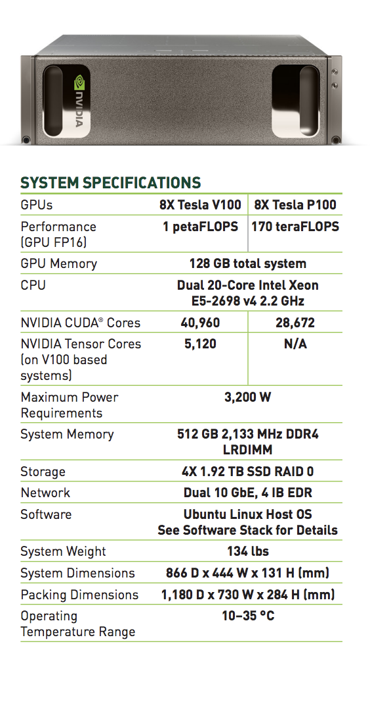

**Compute Server:**

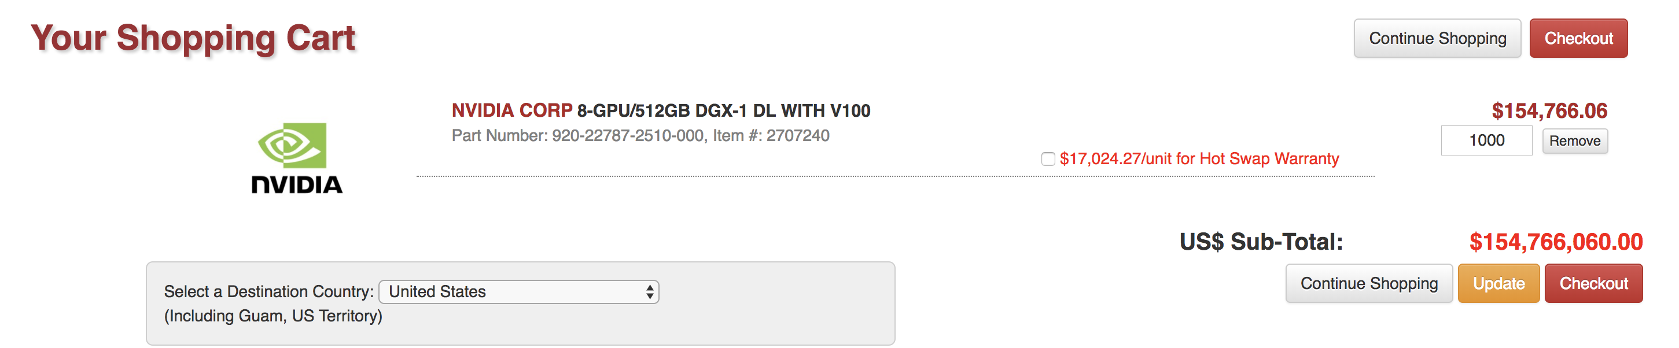

**Storage Servers:**





**Network Switches:**

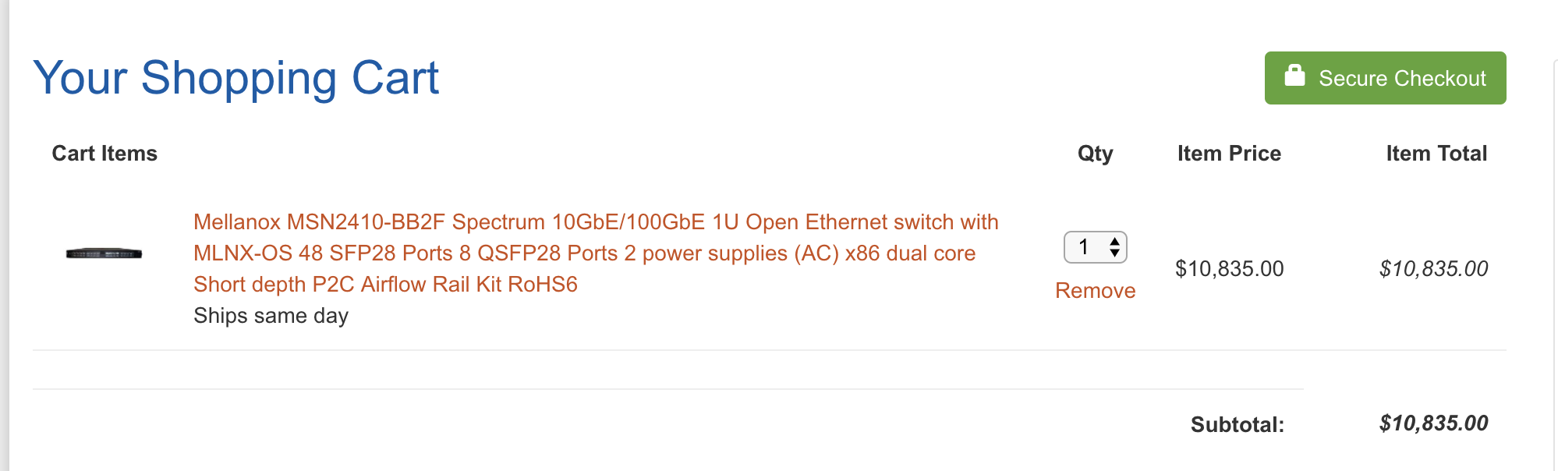

**Network Cables :**

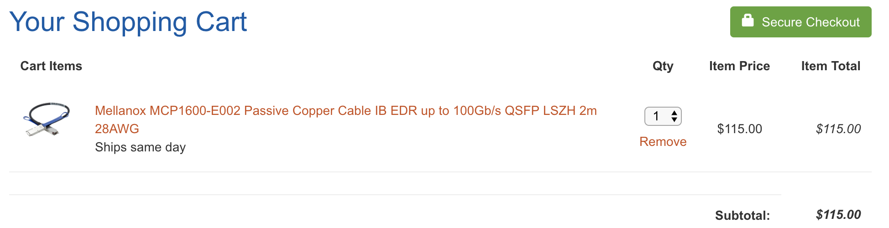

**Racks**:

48U rack selected to fit compute server, storage server and switches. A 2U cabinet selected to fit each of servers and switches.





**Cooling of racks:**

To cool the racks with the server, cooler which can handle two racks has been selected with the optimal cost. The power required is 7kW.



**Administrator:**

We require 3 admin to handle the private cloud as we need more than 2000 servers. Average admin cost comes to $85,000 including perks.



|  |  |  |  |
| --- | --- | --- | --- |
|  | Configuration 1 | Configuration 2 | Configuration 3 |
| Public Cloud (including EC2 and S3) Cost over 5 years, 24/7 operation, with 100% usage | $398,730,121.8 | $7,523,993,218.2 | $1,073,578,998.00 |
| Private Cloud cost over 5 years, 24/7 operation, with 100% usage | $37,682,700.17 | $1,145,488,040.228 | $173,861,520.63 |
| What utilization must be achieved with the private cloud to make the private cloud option more attractive than the public cloud? | 9.4% | 15.22% | 16.19% |

AWS Support business is included in the public cloud cost.

For configuration 1, we get 9.4% utilization as it private cloud takes 37,682,700 and public cloud takes 398,730,121.

For configuration 2, we get 15.22% utilization as it private cloud takes $1,145,488,040 and public cloud takes $7,523,993,218

For configuration 3, we get 16.19% utilization as it private cloud takes $173,861,520 and public cloud takes $ 1,073,578,998

Summary:

It is better to build private cloud in all 3 configurations and the utilizations is way too less and its cheaper to build private cloud then buying the AWS public cloud.